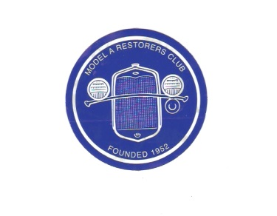**Welcome to the 2017**

**Michigan Model A Round-up**

**August 24-26, 2017**

**Sponsored by the Sparton Horn Region, Model A Restorers Club**

**Registration Information**

Last Name: ________________________________________ First Name: _________________________________________

Spouse: ___________________________________________ Guest/Children: ______________________________________

Address: __________________________________________ City: __________________________ State: _______________

Zip Code: _________________ Region: ____________________ MARC Membership Number: ___________________

Phone #:__________________ Cell Phone #:________________ Email Address: _______________________________

Model A Year: _____________ Body Style: _________________ Trailer parking needed: YES (circle if needed)

**Registration Fee** – One car with one or two attendees = $35.00 (Includes one jacket patch per car)

**-** Please register by August 1, 2017. - Late registration after August 1, 2017 will be an additional $15.00

**-** Each additional adult guest $5.00 - Children under 18 are free.

Registration _______________________ Quantity __________ $35.00 each ======$ ______________

Additional Guest (s) ____ ____________ Quantity __________ $ 5.00 each ======$ ______________

Late Fee (If sent after August 1, 2017) _____________________$15.00 __________ $ ______________

**Friday August 25, 2017**

MIS Speedway Tour with MIS Laps on the track ____________ $ 45.00 __________$ ______________ (includes 1 car & 1 or 2 attendees)

(Monies collected from the MIS Track and Tour are donated to M.I.S Cares)

Friday Welcome Party ______________ Quantity __________ $ 16.50 each _____=$ ______________

Wine Tour __*See Info Page_________ Quantity___________ $ 15.00 each _____=$ ______________

**Saturday August 26, 2017**

Saturday Banquet _____ _____________ Quantity __________ $ 32.00 each ===== $ ______________

Bus Tour to Cascades Falls ___________ Quantity __________ $ 5.00 each ===== $ ______________

Sparton Horn Roundup Polo Shirt (S,M,L) Quantity _________ $ 20.00 each ===== $ ______________

(XL = $23.00 each) __________________ Quantity_________ $ 23.00 each ===== $ ______________

( XXL = $24.00 each)_________________Quantity__________$ 24.00 each ===== $ ______________

Michigan Round-up Hat ______________ Quantity__________$ 15.00 each ===== $ ______________

Additional Round up Jacket Patch _______Quantity__________$ 5.00 each ===== $ ______________ (1 patch included w/ registration)

**+++++++++++++++++++ GRAND TOTAL +++++++++++++++++++++++++ = $______________**

**Please return this registration form and check, made payable to Michigan Model A Roundup 2017, by July 15, 2017.**

**Mail to Greg and Patti Fish For questions contact Greg 517-750-3545**

**879 Meadows Dr. Phil 517-937-8669**

**Jackson MI 49203 Email:** **Spartonhornmodela@gmail.com**

*Cancellation, with a refund, will NOT be accepted after August 15, 2017. A registration confirmation will be emailed to you.

I hereby release, indemnify and hold harmless from any and all liability whatsoever due to my attendance and participation, including any vehicle damage or personal injury arising out of the use of the repair tent, at the 2017 MARC Michigan Roundup, all of the following. The Sparton Horn Model A Restorer’s Club, all club officers, Meet Committee, and the National Meet Region. Submission of this Meet Registration form, either signed or unsigned, constitutes acceptance of this release.

Signed:__________________________________________ Dated: _______________________________